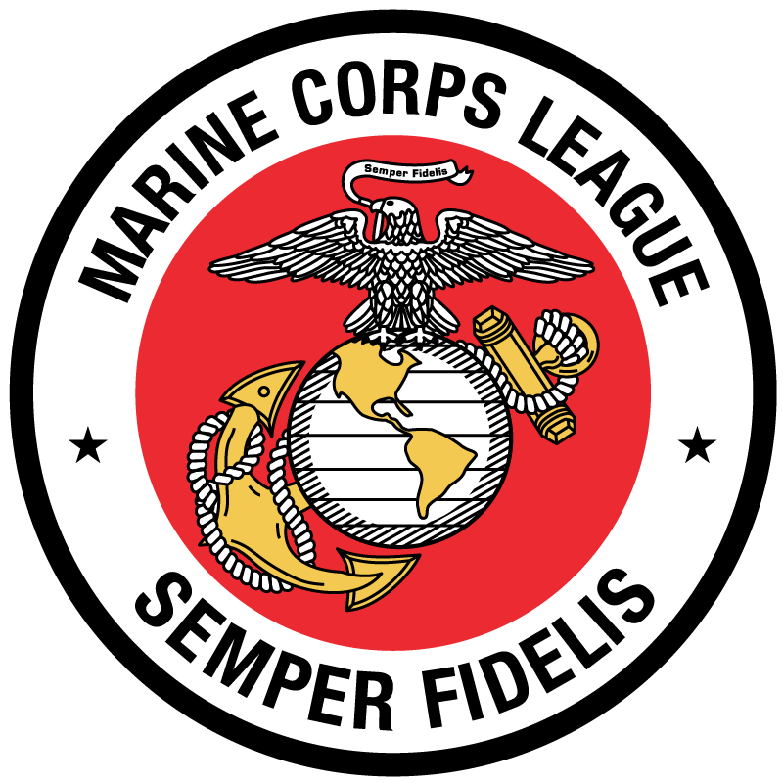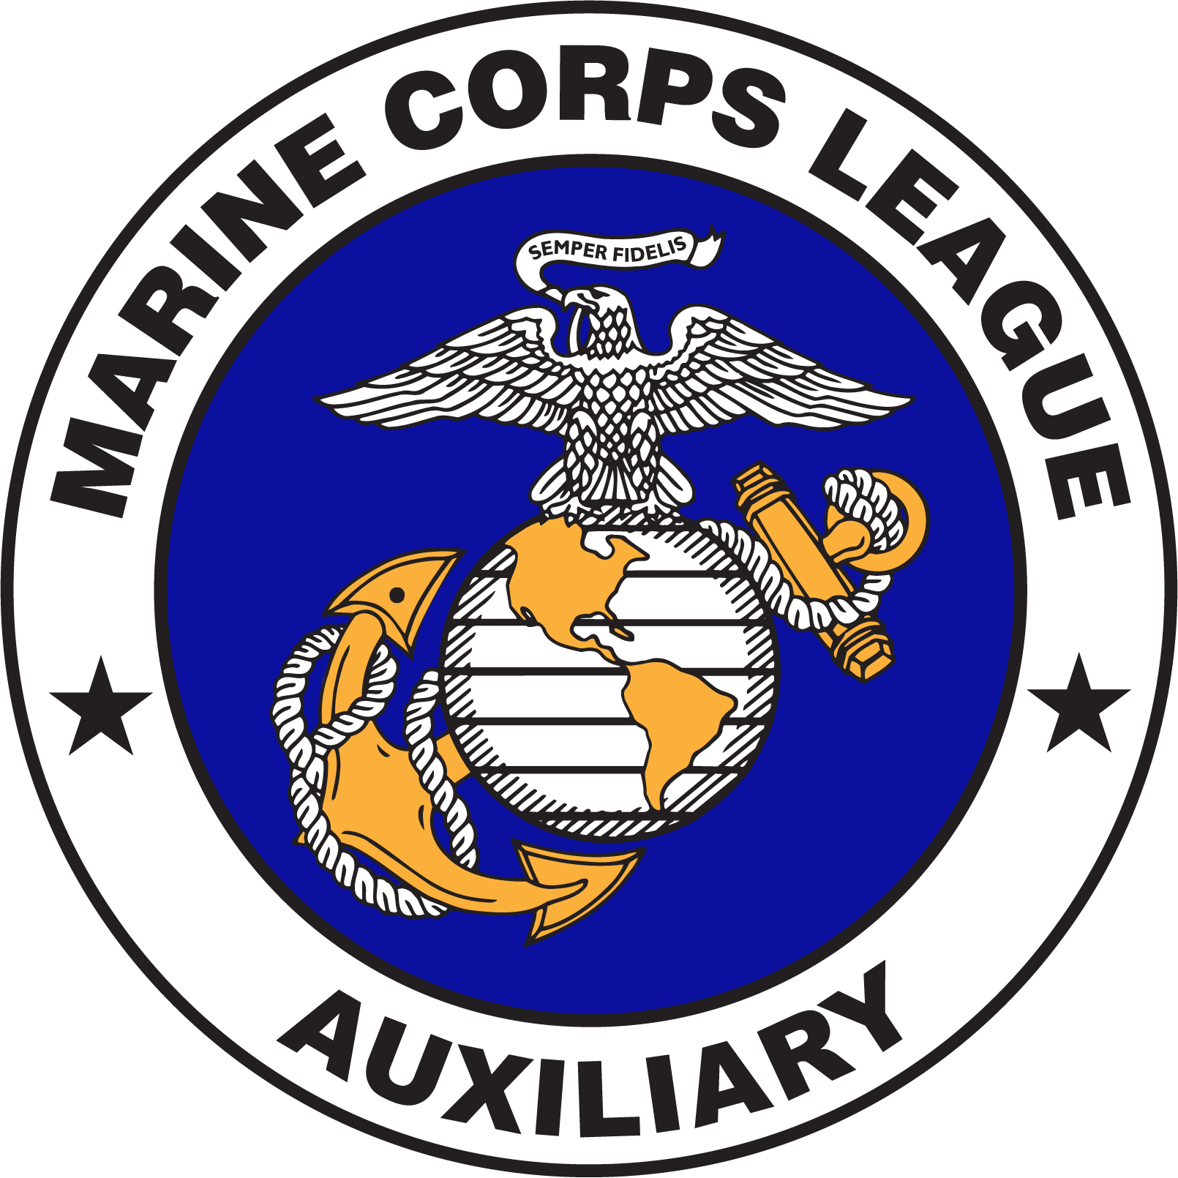Marine Corps League and Auxiliary
2020 Department of Colorado Convention
Hotel and Convention Information
Event Dates: May 1-3, 2020
Event Location:

Double Tree by Hilton
83 East 120th Ave
Thornton, CO 80233

Room Information:
$109 per Room – 2 Breakfast per Room
King / (2) Queen
Reservations: 303-920-8000
*Must be made no later than April 1*

There will be a hospitality room available in the evenings. Light snacks and beverages available. Room location to be given at check-in.
Send Checks to:

Tom Krueger
Broomfield Detachment
DCO Convention
11824 Gray CT
Westminster, CO 80020-5991

Luncheon $_____________

Banquet $_____________

Total $_____________
Banquet Dinner: Buffet Style.
$40/ person Name: __________________________, ________________________,

_________________________________, _________________________________,

_________________________________, __________________________________

Number of people ____________ X $40 =______________
Scholarship Luncheon:
$25 / person including a $5 donation to the Scholarship Fund.
Number of people ______ X $25=___________

